Bukti
Kuesioner UI GreenMetric

Fakultas : ...
Web Address : …

[1] [Pengaturan dan Infrastruktur]
SAMPLE
[1.10] Persentase Area Fakultas yang Ditutupi Dengan Tanaman
(termasuk rumput, kebun, dan lain-lain)

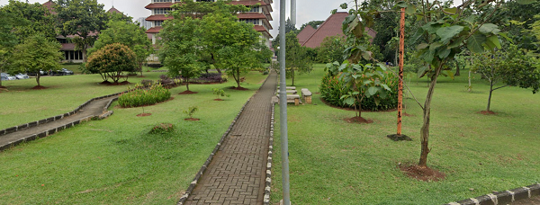 |  | 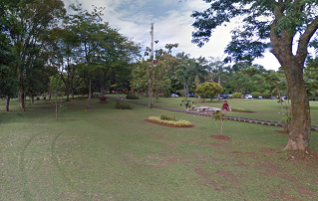
Taman 1 | Taman 2
Example of Total Planted Vegetation Area (Universitas Indonesia, Indonesia)

Description:
(Please describe the planted vegetation area in your campus. The following is an example of the description. You can describe more related items if needed.)

Total planted vegetation area: 193,530 m²
Total Area: 454.678 m2
Percentage area: 43%

Link Bukti tambahan:

