Bukti
Kuesioner UI GreenMetric

Fakultas : ...
Web Address : …

[1] [Pengaturan dan Infrastruktur]
SAMPLE
[1.11] Persentase Area Permukaan di Lingkungan Fakultas yang Dapat Menyerap Air
(termasuk tanah, rumput dan con-block)

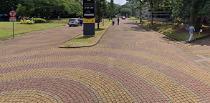 |  | 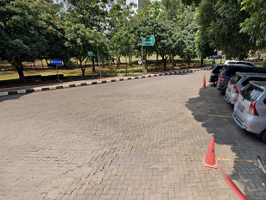
Street 1 | Street 2
Example of Total area on campus for water absorption besides the forest and planted vegetation (Universitas Indonesia, Indonesia)

Description:
(Please describe the Total area on campus for water absorption besides the forest and
planted vegetation area in your campus. The following is an example of the description. You can describe more related items if needed.)

Total water absorption area: 128.915m²
Total Area: 454.678 m²
Percentage area: 28%

Link Bukti tambahan

