Bukti
Kuesioner UI GreenMetric

Fakultas : ...
Web Address : …

[1] [Pengaturan dan Infrastruktur]
SAMPLE
[1.19] Fasilitas Fakultas Untuk Disabilitas, Orang Berkebutuhan Khusus, dan/atau
Fasilitas Penitipan Anak dan Ibu Menyusui

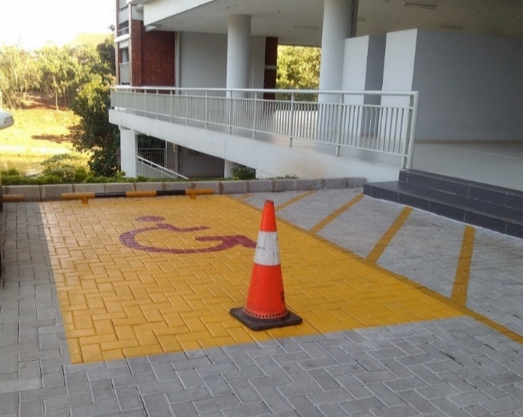 |  | 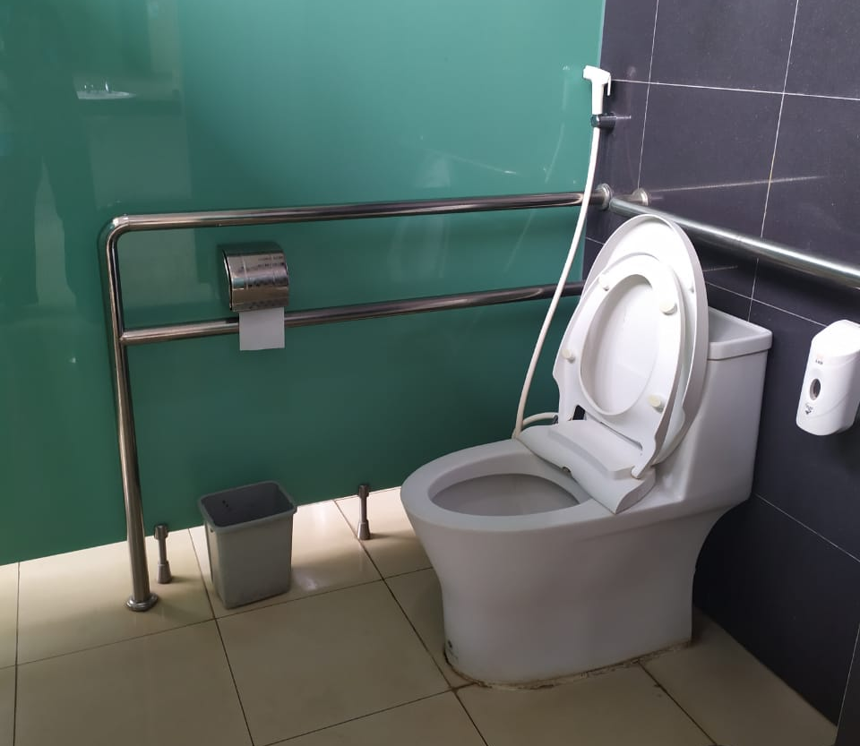
- Disabled parking (Universitas Indonesia, Indonesia) | - Accessible toilet (Universitas Indonesia, Indonesia)
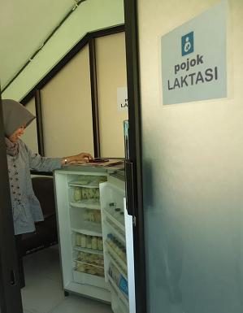
- Lactation Room (Universitas Airlangga, Indonesia)

Description:
(Please describe the Campus facliities for disable, special needs and/or maternity care in your campus. The following is an example of the description. You can describe more related items if needed.)

- Disabled parking for disabled people to park their car which located at the nearest space bulding
- Accessible toilet for disabled people
- Lactation room is private room for staff who are breasfeeding can pump breast milk in private

Link Bukti tambahan:
- https://fkm.unair.ac.id/pojok-laktasi-fkm-unair-fasilitas-yang-memadai-hingga-research-group/

