Bukti
Kuesioner UI GreenMetric

Fakultas : ...
Web Address : …

[1] [Pengaturan dan Infrastruktur]
SAMPLE
[1.20] Fasilitas Keamanan dan Keselamatan Fakultas

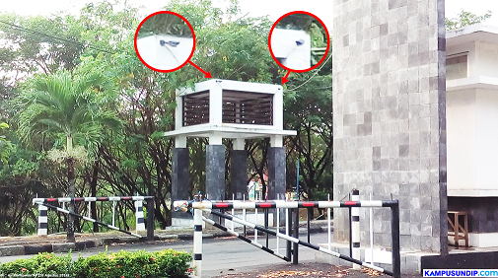 |  | 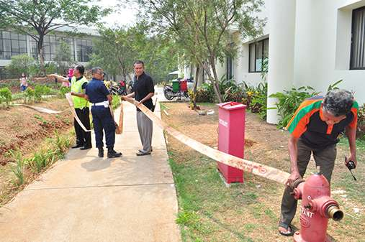
- CCTV in entrance (Universitas Diponegoro, Indonesia) | - Fire Hidrant (Universitas Indonesia, Indonesia)

Description:
(Please describe the Security and safety facilites in your campus. The following is an example of the description. You can describe more related items if needed.)

- CCTV at Universitas Diponegoro’s gate
- Fire Hidrant at Vokasi Universitas Indonesia

Link Bukti tambahan:
- https://vokasi.ui.ac.id/web/pelatihan-k3-simulasi-dan-pelatihan-pemadaman-kebakaran/

