Bukti
Kuesioner UI GreenMetric

Fakultas : ...
Web Address : …

[1] [Pengaturan dan Infrastruktur]
SAMPLE
[1.21] Fasilitas Kesehatan Untuk Kesejahteraan Mahasiswa, Akademisi,
dan Staf Administrasi

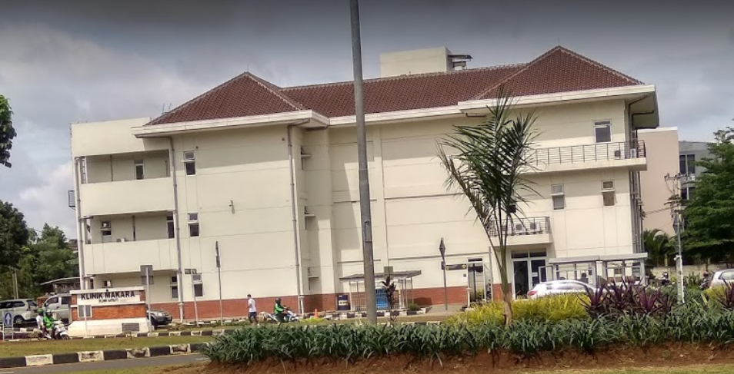
- UI Satellite Clinic

Description:
(Please describe the Health infrastructure facilites in your campus. The following is an example of the description. You can describe more related items if needed.)

- Universitas Indonesia provides health services with comprehensive service support for the entire academic community.

Link Bukti tambahan:
- https://www.ui.ac.id/layanan/poliklinik.html

