Bukti
Kuesioner UI GreenMetric

Fakultas : ...
Web Address : …

[1] [Pengaturan dan Infrastruktur]

[1.22] Program Konservasi di Fakultas: tumbuhan, binatang, sumber daya genetika untuk
SAMPLE
makanan dan pertanian dalam fasilitas konservasi jangka tengah atau panjang

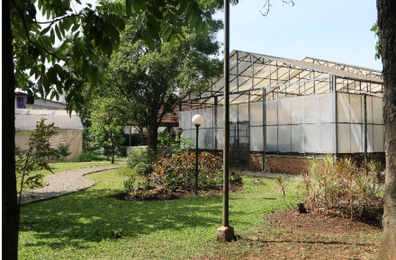 |  | 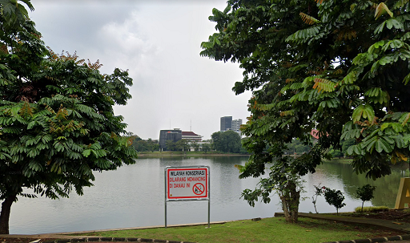
Green House (Telkom University) | Danau Kenanga (Universitas Indonesia)
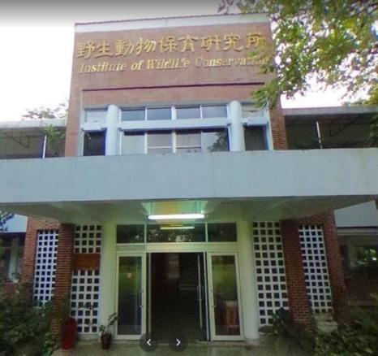 | 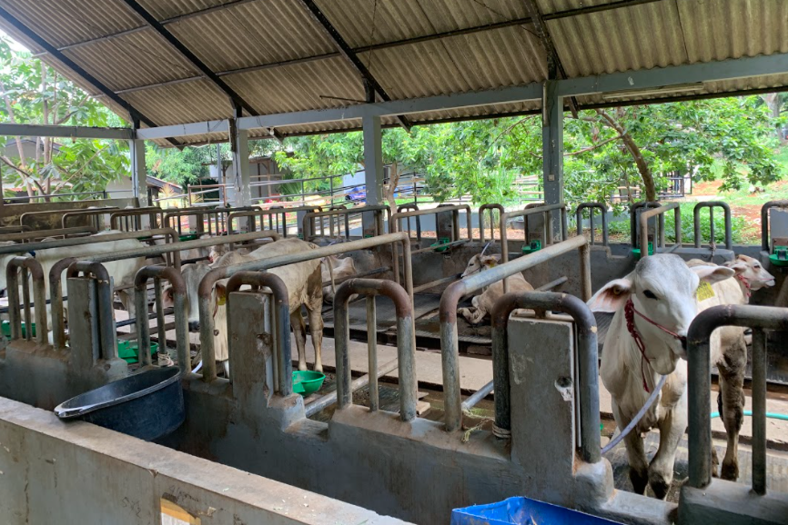
NPUST Institute of Wildlife Conservation | Cattle Farming
Example of Conservation: plant, animal, and wildlife, genetic resources for food and agriculture secured in either medium or long-term conservation facilities

Description:
- Green house for planting vegetables for campus residents
- Danau Kenanga for fish conservation area
- NPUST Institute of Wildlife Conservation
- Cattle Farming at Universitas Diponegoro

Link Bukti tambahan:

