Bukti
Kuesioner UI GreenMetric

Fakultas : ...
Web Address : …
Contoh
[1] Pengaturan dan Infrastruktur (SI)

[1.24] Perencanaan, pelaksanaan, monitoring dan/atau evaluasi semua program terkait penataan dan infrastruktur melalui pemanfaatan TIK

Stage | Activities/Programs | ICT Utilization | Evidence | Timeline | Responsible Team/Department
Planning | Development of a digital campus master plan | Use of project management software and digital collaboration tools for planning and coordination | Project proposals, meeting minutes, digital planning documents | Jan 2024 - Mar 2024 | ICT Committee, Campus Planning Dept
Implementation | Installation of smart classroom technology | Deployment of interactive whiteboards, digital projectors, and video conferencing systems | Purchase orders, installation reports, user manuals | Apr 2024 - Jun 2024 | ICT Dept, Facility Management
Monitoring | Regular audits of network infrastructure and classroom technology usage | Network monitoring tools, usage analytics software | Audit reports, network performance metrics, usage statistics | Jul 2024 - Ongoing | ICT Dept, Academic Affairs
Evaluation | Assessment of ICT impact on teaching and learning outcomes | Surveys, feedback forms, and data analysis tools | Survey results, feedback summaries, academic performance data | Dec 2024 | Institutional R

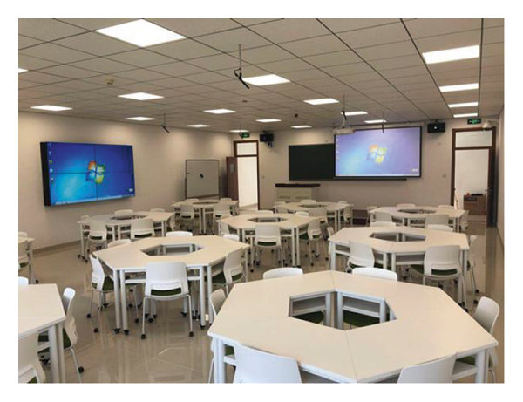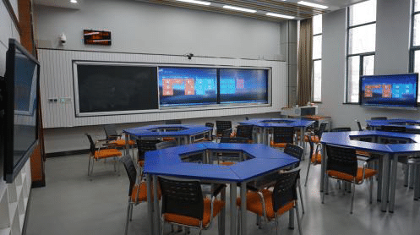
Installation of smart classroom technology

Deskripsi:
(Please describe planning, implementation, monitoring and/or evaluation of all programs related to Setting and Infrastructure through the utilization of Information and Communication Technology (ICT). You can describe more related items if needed.)
Planning: Development of a digital campus master plan
- Activities/Programs: In this stage, the campus sets out to create a comprehensive digital master plan. This involves identifying needs, setting objectives, and developing strategies for ICT integration across campus infrastructure.
- ICT Utilization: Project management software (e.g., Microsoft Project, Asana) and digital collaboration tools (e.g., Slack, Microsoft Teams) are used to coordinate planning activities, document discussions, and manage timelines.
- Evidence: Evidence for this stage includes project proposals that outline the scope and objectives of the master plan, minutes from planning meetings detailing discussions and decisions made, and digital documents that encapsulate the master plan.
- Timeline: January 2024 - March 2024
- Responsible Team/Department: ICT Committee, Campus Planning Department
Implementation: Installation of smart classroom technology
- Activities/Programs: This phase focuses on deploying new technologies within classrooms to enhance the teaching and learning experience. This includes the installation of interactive whiteboards, digital projectors, and video conferencing systems.
- ICT Utilization: Technologies such as interactive whiteboards (e.g., SMART Boards), digital projectors, and video conferencing systems (e.g., Zoom, Microsoft Teams) are installed.
- Evidence: Purchase orders for the new technology, installation reports from vendors or in-house staff, and user manuals for the new equipment serve as evidence.
- Timeline: April 2024 - June 2024
- Responsible Team/Department: ICT Department, Facility Management
Monitoring: Regular audits of network infrastructure and classroom technology usage
- Activities/Programs: Continuous monitoring of the campus network infrastructure and classroom technology usage to ensure optimal performance and identify areas for improvement.
- ICT Utilization: Network monitoring tools (e.g., Nagios, PRTG Network Monitor) and usage analytics software (e.g., Google Analytics for education) are employed to track network performance and technology usage.
- Evidence: Audit reports that summarize the findings of regular checks, network performance metrics showing uptime and downtime, and usage statistics from classroom technologies.
- Timeline: July 2024 - Ongoing
- Responsible Team/Department: ICT Department, Academic Affairs
Evaluation: Assessment of ICT impact on teaching and learning outcomes
- Activities/Programs: Evaluate the effectiveness of the implemented ICT solutions in enhancing educational outcomes. This involves collecting feedback from stakeholders and analyzing data on academic performance.
- ICT Utilization: Surveys and feedback forms distributed via digital platforms (e.g., Google Forms, SurveyMonkey), and data analysis tools (e.g., SPSS, Excel) to evaluate the collected data.
- Evidence: Survey results showing the perception of the new technology by students and faculty, summaries of feedback collected, and academic performance data comparing results before and after the implementation.
- Timeline: December 2024
- Responsible Team/Department: Institutional Research, ICT Department

Link Tambahan:

