Bukti
Kuesioner UI GreenMetric

Fakultas : ...
Wesite : …
Contoh
[1] Pengaturan dan Infrastruktur (SI)

[1.24] Dampak program Penataan dan Infrastruktur dalam mendukung Tujuan Pembangunan Berkelanjutan (TPB)/SDGs

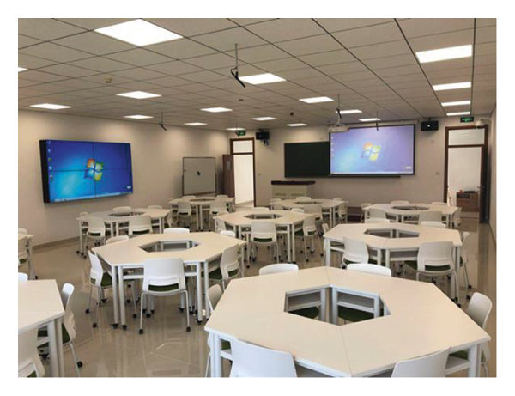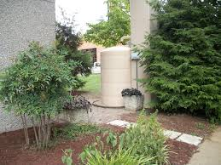
Example

Deskripsi:
Mohon tunjukkan sejauh mana program Pengaturan dan Infrastruktur di fakultas Anda berkontribusi terhadap pencapaian Tujuan Pembangunan Berkelanjutan (TPB) PBB
The faculty has implemented various infrastructure and environmental setting programs that directly contribute to the achievement or impact of Sustainable Development Goals (SDGs). The key programs include:
- Construction and revitalization of energy-efficient buildings based on green building principles, equipped with natural lighting and ventilation systems, as well as solar panels for renewable energy.
- Expansion of green open spaces (GOS) to improve air quality and support local biodiversity.
- Implementation of rainwater harvesting systems and infiltration wells to manage stormwater and conserve groundwater.
- Provision of eco-friendly and inclusive sanitation facilities, including accessible toilets and waste separation units.
- Development of pedestrian walkways, bicycle lanes, and integration with public transportation to promote low-emission mobility.
- Utilization of digital technology to monitor energy and water consumption, as well as to manage infrastructure assets sustainably.
- Establishment of motor-vehicle-free zones in certain campus areas to promote green mobility and reduce emissions.
- Construction of inclusive learning facilities and open spaces that are accessible to all, including persons with disabilities.
- Collaboration with external partners and government agencies in the development of a sustainable campus master plan.
These programs support the following SDGs: 1, 3, 4, 5, 6, 7, 8, 9, 10, 11, 12, 13, 14, 15, and 17, addressing key aspects such as poverty alleviation (through equitable access to public space and facilities), good health and well-being, quality education, gender equality, clean water and sanitation, affordable and clean energy, green economic growth, resilient infrastructure, reduced inequalities, sustainable cities and communities, responsible consumption and production, climate action, and the protection of terrestrial and aquatic ecosystems, as well as global partnerships.
Link Tambahan:

