Bukti
Kuesioner UI GreenMetric

Fakultas : ...
Web Address : …

[1] Pengaturan dan Infrastruktur

[1.3] Jumlah Gedung Fakultas

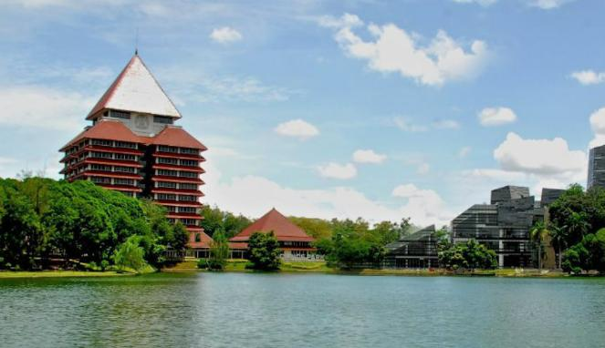 | Contoh Gedung Kampus Depok Universitas Indonesia
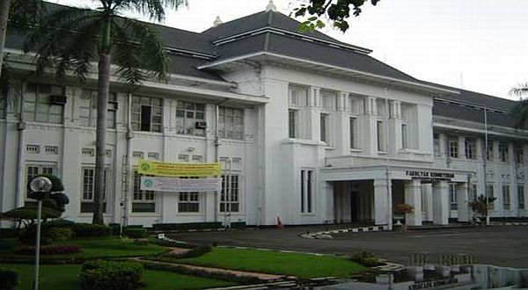 | Contoh Gedung, Kampus Salemba Universitas Indonesia

Deskripsi:
..................................................................................................................................................................
..................................................................................................................................................................
..................................................................................................................................................................
..................................................................................................................................................................
..................................................................................................................................................................

