Bukti
Kuesioner UI GreenMetric

Fakultas : ...
Web Address : …

[1] Pengaturan dan Infrastruktur

[1.5] Total area fakultas (meter²)

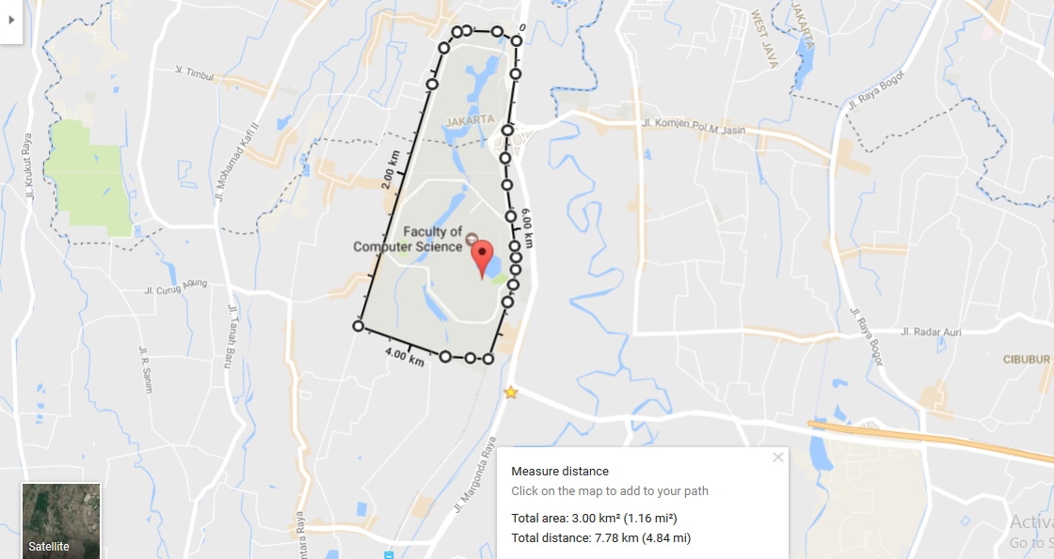
Contoh total area kampus (University of Indonesia, Indonesia)

Deskripsi:

Total area: 3.00 km² (1.16 mi²) = 3.000.0000 m²
Total jarak: 7.78 km (4.84 mi) = 7.780 m

