Bukti
Kuesioner UI GreenMetric

Fakultas : ...
Web Address : …

[3] Limbah

[3.11] Penanganan limbah beracun di Fakultas (apakah limbah beracun ditangani secara terpisah, misalnya dengan mengelompokkan dan dikumpulkan)

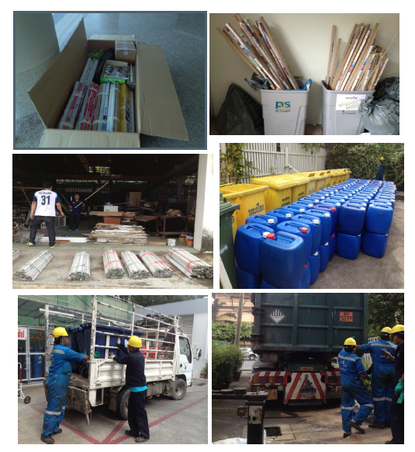
Contoh Penanganan Limbah Beracun (Mahidol University, Thailand)

Deskripsi:
..................................................................................................................................................................
..................................................................................................................................................................
..................................................................................................................................................................

