Bukti
Kuesioner UI GreenMetric

Fakultas : ...
Web Address : …

[3] Limbah

[3.12] Pembuangan limbah cair (metode utama dari pengolahan limbah) (pilih opsi yang paling menggambarkan cara pembuangan air limbah)

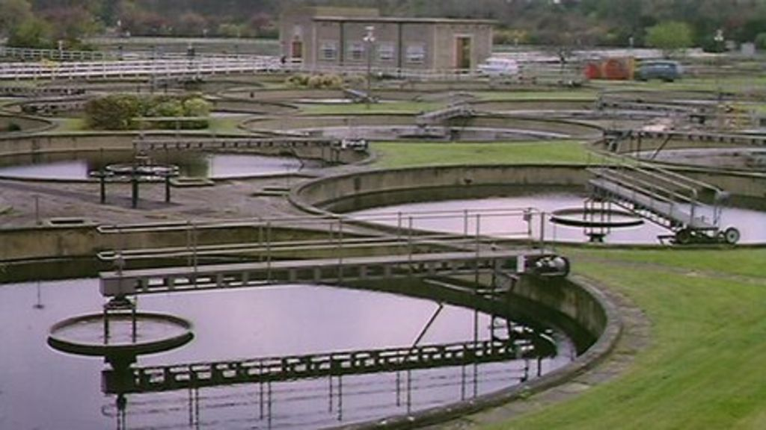
Contoh Pembuangan limbah cair (Nottingham Trent University, UK)

Deskripsi:
..................................................................................................................................................................
..................................................................................................................................................................
..................................................................................................................................................................
..................................................................................................................................................................

