Bukti
Kuesioner UI GreenMetric

Fakultas :
Web Address : …

[3] Limbah

[3.14] Perencanaan, pelaksanaan, monitoring dan/atau evaluasi semua program terkait pengelolaan limbah melalui pemanfaatan TIK

Stage | Activities/Programs | ICT Utilization | Evidence | Timeline | Responsible Team/Department
Planning | Develop 3R strategy, set targets for waste reduction | Waste audit software, data analytics tools | Strategic plan documents, waste audit reports | Jan 2024 - Feb 2024 | Sustainability Office, ICT Dept
Implementation | Install recycling bins, initiate waste segregation | RFID tags for bins, waste management software | Installation logs, waste segregation reports | Mar 2024 - Apr 2024 | Facility Management, ICT Dept
Monitoring | Track waste collection and recycling rates | Smart waste bins, real-time tracking software | Recycling rate reports, efficiency analytics | Ongoing | Sustainability Office, ICT Dept
Evaluation | Assess effectiveness of 3R program | Data analysis tools, feedback systems | Program evaluation reports, stakeholder feedback | Annually | Sustainability Office, ICT Dept

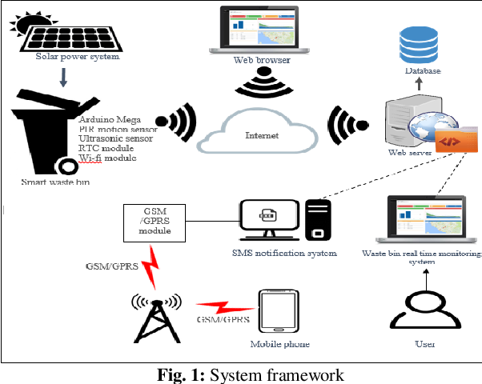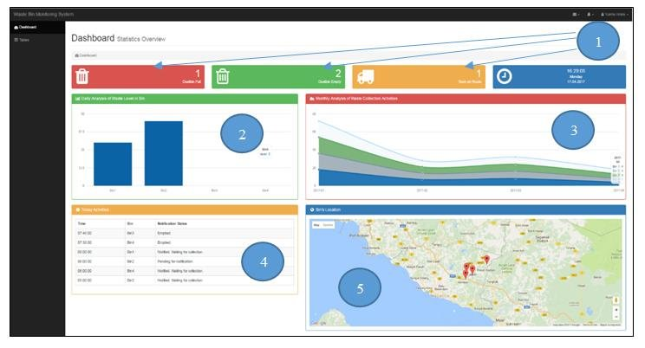
Smart waste bins with real-time tracking software to monitor waste collection

Deskripsi:
(Please describe planning, implementation, monitoring and/or evaluation of all programs related to Waste Management through the utilization of Information and Communication Technology (ICT). You can describe more related items if needed.)
- Planning: Develop a comprehensive 3R strategy and set measurable targets for waste reduction. Use waste audit software and data analytics tools to analyze current waste generation and identify areas for improvement.
- Implementation: Install recycling bins across the campus and initiate waste segregation programs. Employ RFID tags for bins to monitor usage and waste management software to track waste segregation.
- Monitoring: Track the collection and recycling rates of waste. Use smart waste bins with real-time tracking software to monitor waste collection.
- Evaluation: Assess the effectiveness of the 3R program. Utilize data analysis tools and feedback systems to evaluate the program.
Link tambahan:

