Bukti
Kuesioner UI GreenMetric

Fakultas :
Web Address : …
SAMPLE
[3] Limbah

[3.20] Dampak program Pengelolaan Limbah dalam mendukung Tujuan Pembangunan Berkelanjutan (TPB)/SDGs

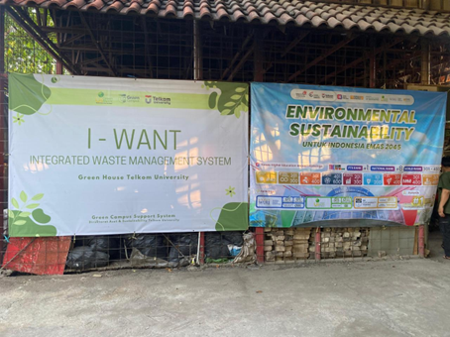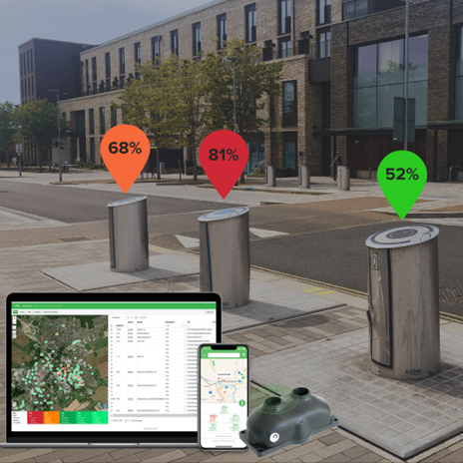
Example

Description:
(Please describe Impact of Waste Management programs in supporting the Sustainable Development Goals. You can describe more related items if needed.)
The university has undertaken a wide range of waste management programs that contribute significantly to the achievement of the 17 Sustainable Development Goals (SDGs). These initiatives reflect a strong institutional commitment to reducing environmental impact, promoting the circular economy, and fostering responsible consumption. Key programs include:
- Implementation of comprehensive waste segregation systems across campus, separating organic, inorganic, hazardous, recyclable, and e-waste at the source.
- Operation of composting facilities to process organic waste into fertilizer used for campus landscaping and urban farming projects.
- Establishment of recycling stations and partnerships with licensed waste vendors to process paper, plastics, glass, metals, and electronics.
- Organization of e-waste collection drives and disposal campaigns to manage electronic waste in accordance with environmental regulations.
- Campus-wide zero-waste campaigns, encouraging reduction, reuse, and recycling through awareness events, signage, and student-led initiatives.
- Ban or reduction of single-use plastics in canteens, vending machines, and university events, replacing them with reusable alternatives.
- Digitalization of administrative processes to reduce paper consumption and promote environmentally-friendly operations.
- Inclusion of waste management topics in the academic curriculum, research projects, and student theses focused on lifecycle analysis, waste-to-energy, and sustainable packaging.
- Installation of smart bins or waste monitoring systems to track collection volumes and optimize waste handling logistics.
- Collaboration with local governments, NGOs, and private sectors to strengthen regional waste governance and promote circular economy innovation.
These efforts directly support SDGs 3, 4, 6, 9, 11, 12, 13, 14, 15, and 17, and contribute indirectly to others, including:
- SDG 3 – Reducing health risks through safe waste handling and sanitation
- SDG 4 – Educating students about sustainable materials management
- SDG 6 – Preventing water contamination through proper waste disposal
- SDG 9 – Driving innovation in waste treatment and recycling technology
- SDG 11 – Advancing sustainable campus infrastructure and communities
- SDG 12 – Promoting responsible consumption and waste reduction
- SDG 13 – Lowering emissions from waste and enhancing climate action
- SDG 14 – Minimizing land and marine pollution from solid waste
- SDG 15 – Protecting ecosystems through sustainable waste practices
- SDG 17 – Building waste partnerships for policy and practice improvement
Link Bukti Tambahan
:

