Bukti
Kuesioner UI GreenMetric

Fakultas : ...
Web Address : …

[3] Limbah

[3.8] Pengolahan Limbah Organik (sampah, limbah sayuran dan tumbuhan) (pilih opsi yang paling menggambarkan situasi Fakultas dalam pengolahan limbah organik)

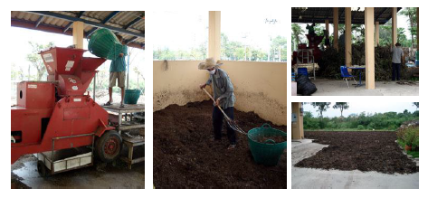
Contoh Pengolahan Limbah Organik (Mahidol University, Thailand)

Deskripsi:
..................................................................................................................................................................
..................................................................................................................................................................
..................................................................................................................................................................
..................................................................................................................................................................

