Bukti
Kuesioner UI GreenMetric

Fakultas : ...
Web Address : …

[4] Air

[4.2] Implementasi Program Pemanfaatan Air Daur Ulang di Fakultas

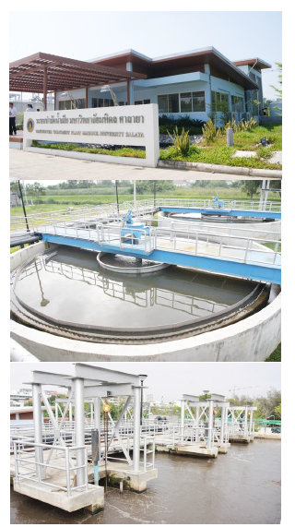 | 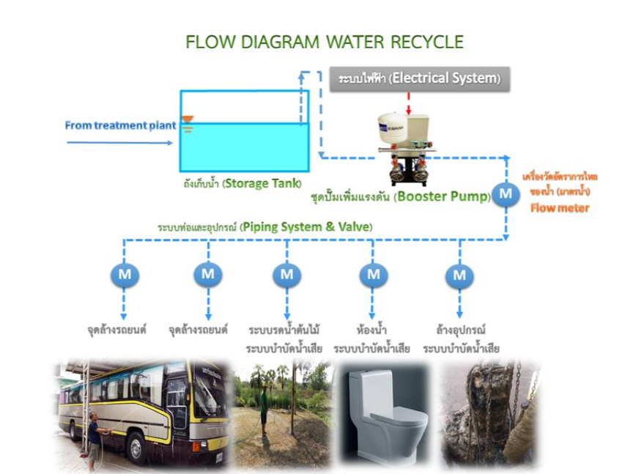
Instalasi pengolahan air limbah (Mahidol University, Thailand) | Air Daur Ulang yang Digunakan (Mahidol University, Thailand)

Deskripsi:
..................................................................................................................................................................
..................................................................................................................................................................
..................................................................................................................................................................
..................................................................................................................................................................

