Bukti
Kuesioner UI GreenMetric

Fakultas : ...
Web Address : …

[4] Air

[4.3] Penggunaan Peralatan Hemat Air (misalnya keran sensor otomatis, autoflush toilet dll)

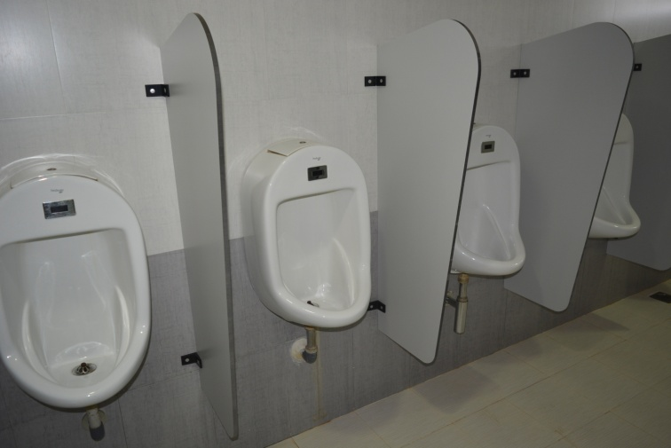 | 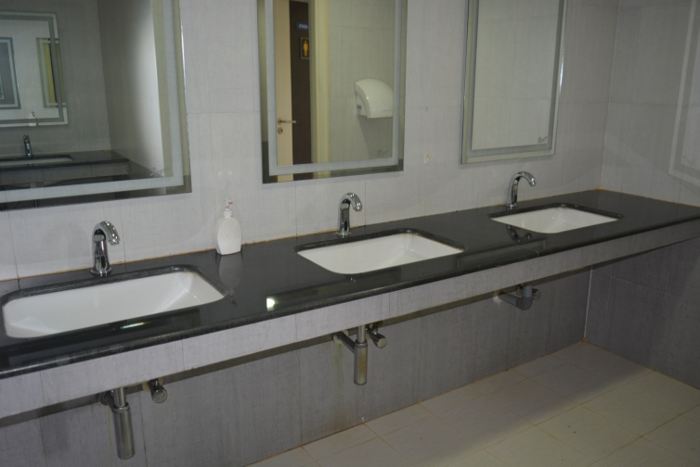
1

Deskripsi:
- Contoh Penggunaan Peralatan Hemat Air (misalnya keran sensor otomatis, autoflush toilet dll) (Institute for Financial Management and Research, India)

Peralatan | Total | Total peralatan hemat air | Persen
Toilet | 250 | 150 | 60%
Wastafel | 150 | 100 | 66%
Dll | … | … | …
 |  | Rata-rata | 63%

