Bukti
Kuesioner UI GreenMetric

Fakultas : ...
Web Address : …
SAMPLE
[4] Air (WR)

[4.6] Pengendalian Pencemaran Air di Area Fakultas
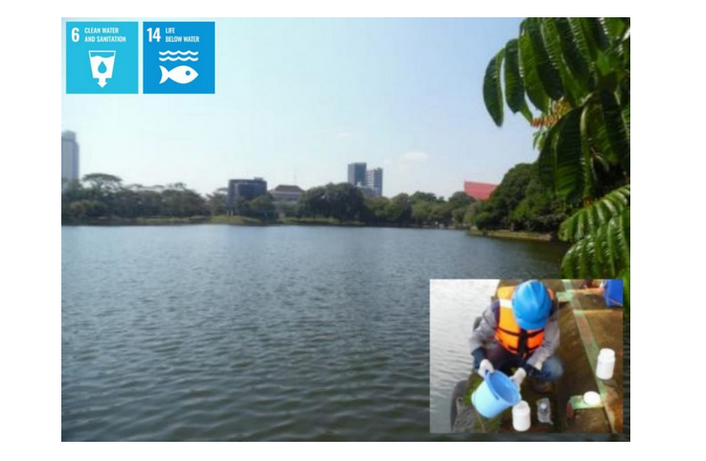
Water quality sampling and monitoring at Kenanga Lake Universitas Indonesia

Description:
(Please describe water pollution control in campus area. The following is an example of the description. You can describe more related items if needed.)

Additional evidence link (i.e., for videos, more images, or other files that are not included in this file):
https://k3l.ui.ac.id/konservasi-perairan-dan-lingkungan-pemantauan-dan-evaluasi-kualitas-lingkungan-kawasan-kampus-ui/

.

