Bukti
Kuesioner UI GreenMetric

Fakultas : ...
Website : …
SAMPLE
[4] Air (WR)

[4.7] Perencanaan, pelaksanaan, monitoring dan/atau evaluasi semua program terkait pengelolaan air melalui pemanfaatan TIK

Stage | Activities/Programs | ICT Utilization | Evidence | Timeline | Responsible Team/Department
Planning | Develop water conservation strategy, set targets | Water usage analytics software | Strategic plan documents, water usage reports | Jan 2024 - Feb 2024 | Sustainability Office, ICT Dept
Implementation | Install water-saving fixtures, promote awareness | Smart meters, water-saving app | Installation logs, awareness campaign reports | Mar 2024 - Apr 2024 | Facility Management, ICT Dept
Monitoring | Track water usage and savings | Real-time monitoring software | Water usage reports, savings analytics | Ongoing | Sustainability Office, ICT Dept
Evaluation | Assess effectiveness of conservation programs | Data analysis tools, feedback systems | Program evaluation reports, stakeholder feedback | Annually | Sustainability Office, ICT Dept

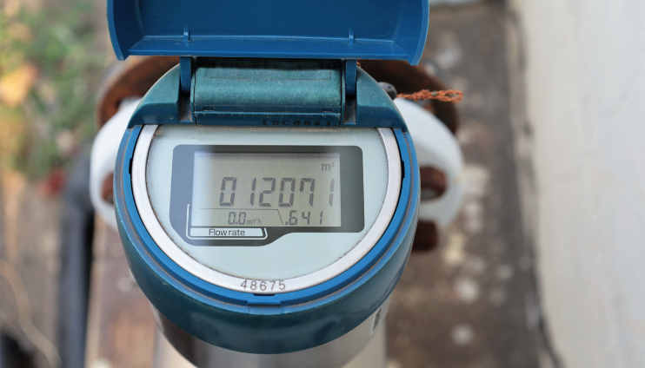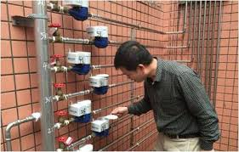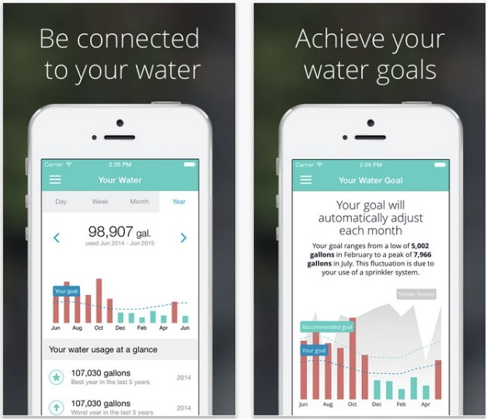
Smart water meter and water-saving app

Deskripsi:
(Please describe planning, implementation, monitoring and/or evaluation of all programs related to Water Management through the utilization of Information and Communication Technology (ICT). You can describe more related items if needed.)
- Planning: Develop a comprehensive water conservation strategy and set measurable targets for water savings. Use water usage analytics software to analyze current water consumption and identify potential savings.
- Implementation: Install water-saving fixtures (e.g., low-flow taps and toilets) across the campus and promote water conservation awareness. Employ smart meters to monitor water usage and a water-saving app to educate and engage the campus community.
- Monitoring: Track water usage and calculate water savings from conservation measures. Use real-time monitoring software to continuously track water usage and identify trends.
- Evaluation: Assess the effectiveness of the water conservation programs. Utilize data analysis tools and feedback systems to evaluate the program.
Link Tambahan:

