Bukti
Kuesioner UI GreenMetric

Fakultas : ...
Web Address : …

[5] Transportasi (TR)

[5.19] Perencanaan, pelaksanaan, monitoring dan/atau evaluasi semua program terkait transportasi melalui pemanfaatan TIK

Stage | Activities/Programs | ICT Utilization | Evidence | Timeline | Responsible Team/Department
Planning | Assess transportation needs, plan shuttle routes | Transport planning software | Needs assessment reports, route plans | Jan 2024 - Feb 2024 | Transportation Office, ICT Dept
Implementation | Deploy shuttle services, launch mobile app | GPS tracking, shuttle scheduling app | Service launch reports, app usage data | Mar 2024 - Apr 2024 | Transportation Office, ICT Dept
Monitoring | Track shuttle usage, optimize routes | Real-time tracking software | Usage analytics, optimization reports | Ongoing | Transportation Office, ICT Dept
Evaluation | Evaluate shuttle service efficiency | Data analysis tools, user feedback surveys | Efficiency reports, survey results | Annually | Transportation Office, ICT Dept

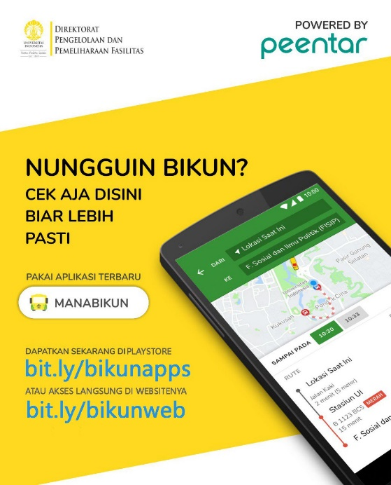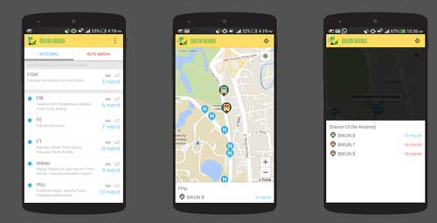
shuttle scheduling app

Deskripsi:
(Please describe planning, implementation, monitoring and/or evaluation of all programs related to Transportation through the utilization of Information and Communication Technology (ICT). You can describe more related items if needed.)
- Planning: Assess the transportation needs of the campus community and plan efficient shuttle routes to meet these needs. Utilize transport planning software to analyze data on campus traffic, student and staff schedules, and optimal shuttle routes.
- Implementation: Deploy shuttle services according to the planned routes and launch a mobile app for real-time shuttle information. Use GPS tracking for shuttles and a shuttle scheduling app to provide real-time updates to users.
- Monitoring: Track shuttle usage and optimize routes based on usage data. Employ real-time tracking software to monitor shuttle locations and passenger numbers.
- Evaluation: Evaluate the efficiency and effectiveness of the shuttle services. Use data analysis tools to assess performance metrics and gather user feedback through surveys.
Link tambahan:

