Bukti
Kuesioner UI GreenMetric

Fakultas : ...
Web Address : …

[5] Transportasi (TR)

[5.19] Dampak program Transportasi dalam mendukung Tujuan Pembangunan Berkelanjutan (TPB)/SDGs

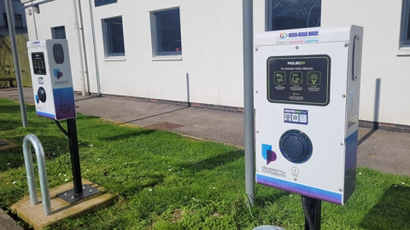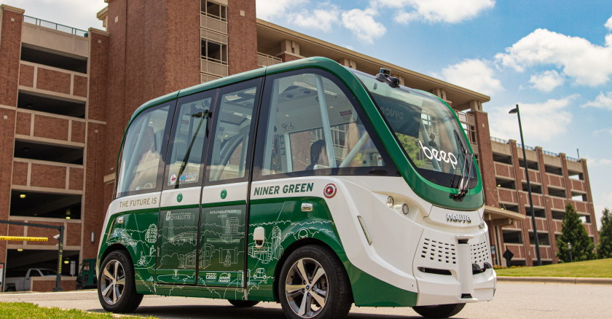
Example

Deskripsi:
(Mohon tunjukkan sejauh mana program Transportasi di fakultas Anda berkontribusi terhadap pencapaian Tujuan Pembangunan Berkelanjutan (TPB) PBB.)
The faculty has undertaken a wide range of sustainable transportation programs that contribute significantly to the achievement of the 17 Sustainable Development Goals (SDGs). These initiatives reflect a strong institutional commitment to low-carbon mobility, reduction of air pollution, and the creation of safe, inclusive, and accessible transport systems. Key programs include:
- Development of integrated pedestrian pathways and dedicated bicycle lanes across campus to encourage non-motorized transport.
- Operation of low-emission campus shuttle buses, including electric or hybrid vehicles, to reduce reliance on personal cars.
- Installation of electric vehicle (EV) charging stations to support the transition to cleaner transportation alternatives.
- Designation of car-free zones and limited-access areas to minimize traffic congestion and air pollution within campus.
- Provision of bicycle-sharing programs and supporting infrastructure (parking racks, lockers, repair stations) to enhance cycling convenience.
- Implementation of a vehicle restriction policy, including license plate control or limited parking permits for students and staff.
- Integration with public transportation systems, including campus bus terminals or last-mile shuttle services, to improve accessibility.
- Awareness campaigns and mobility education initiatives promoting safe, healthy, and sustainable transport behavior.
- Real-time digital tracking tools to monitor shuttle schedules, optimize routes, and support user convenience.
- Collaboration with government and urban planning stakeholders to align university mobility strategies with broader city transport plans.
These efforts directly support SDGs 3, 4, 7, 9, 11, 12, 13, and 17, and contribute indirectly to others, including:
- SDG 3 – Reducing exposure to air pollution and promoting healthy, active lifestyles
- SDG 4 – Ensuring inclusive access to education through safe and reliable campus transport
- SDG 7 – Promoting the use of clean energy in transportation
- SDG 9 – Supporting innovation in sustainable transport infrastructure
- SDG 11 – Building inclusive, safe, and sustainable urban mobility systems
- SDG 12 – Encouraging responsible use of resources through shared mobility
- SDG 13 – Lowering carbon emissions through low-impact transportation
- SDG 17 – Strengthening partnerships to develop integrated, sustainable transport networks
Link Tambahan:

