Bukti
Kuesioner UI GreenMetric

Fakultas : ...
Web Address : …

[5] Transportasi

[5.5] Tipe operasional shuttle Fakultas

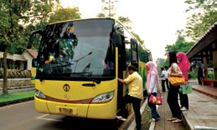 | 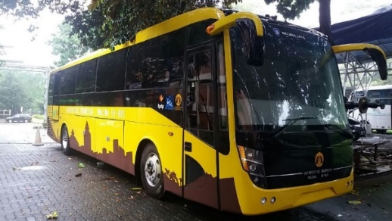
Bus Kampus | Electric Bus
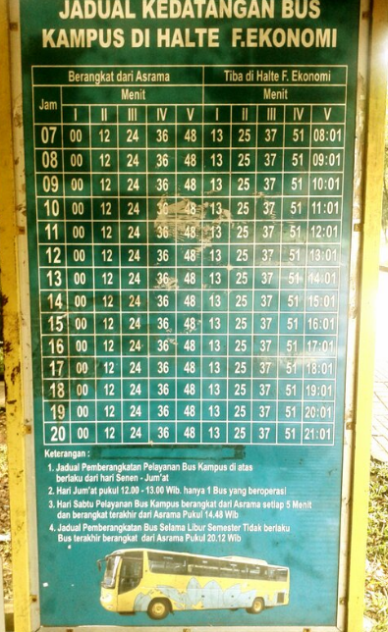 | 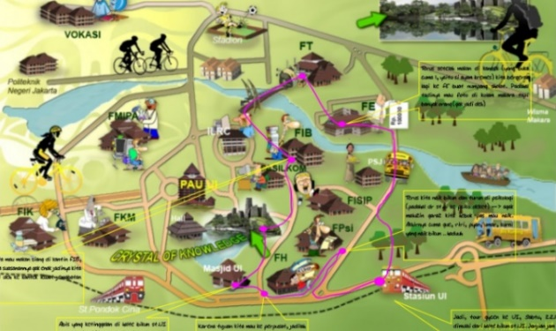
Jadwal Bus | Rute Bus
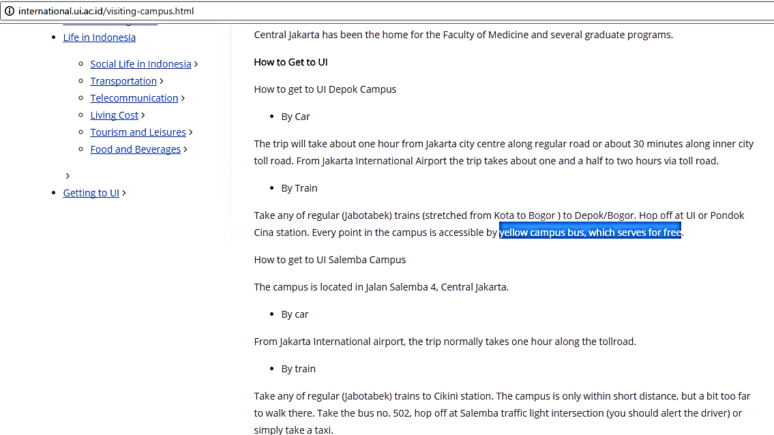
Example of Shuttle service is available and free (Universitas Indonesia, Indonesia/ http://international.ui.ac.id/visiting-campus.html )

Description:
..................................................................................................................................................................
..................................................................................................................................................................
..................................................................................................................................................................

