Bukti
Kuesioner UI GreenMetric

Fakultas : ...
Web Address : …

[5] Transportasi

[5.9] Kebijakan mengenai kendaraan bebas emisi di fakultas

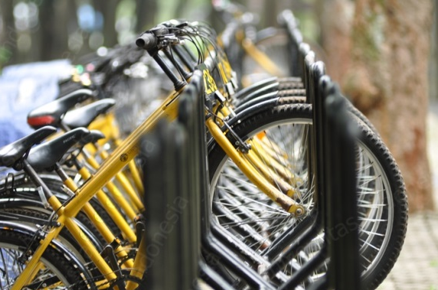 | 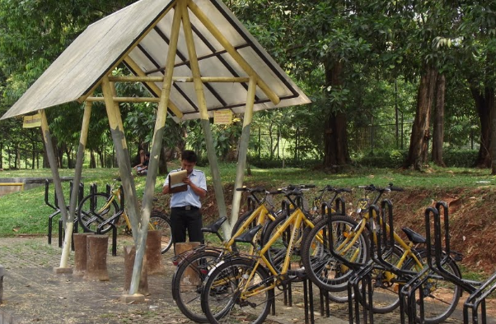
Contoh Parkir Sepeda (University of Indonesia, Indonesia) | Contoh Parkir Sepeda (University of Indonesia, Indonesia)
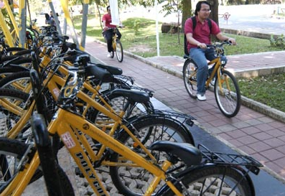 | 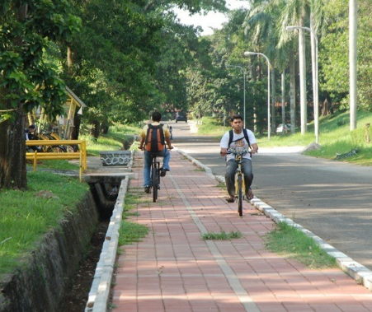
Contoh Jalur Sepeda (University of Indonesia, Indonesia) | Contoh Jalur Sepeda (University of Indonesia, Indonesia)

Deskripsi:
..................................................................................................................................................................
..................................................................................................................................................................
..................................................................................................................................................................
..................................................................................................................................................................
..................................................................................................................................................................
..................................................................................................................................................................
..................................................................................................................................................................

